SCHOOLOFCOMPUTER SCIENCE AND ARTIFICIAL INTELLIGENCE |  |  |  |  | DEPARTMENTOFCOMPUTER SCIENCE ENGINEERING
ProgramName:B. Tech |  |  |  | AssignmentType: Lab |  |  | AcademicYear:2025-2026
CourseCoordinatorName |  |  |  | Venkataramana Veeramsetty
Instructor(s)Name |  |  |  | Dr. V. Venkataramana (Co-ordinator)  Dr. T. Sampath Kumar  Dr. Pramoda Patro  Dr. Brij Kishor Tiwari  Dr.J.Ravichander  Dr. Mohammand Ali Shaik  Dr. Anirodh Kumar  Mr. S.Naresh Kumar  Dr. RAJESH VELPULA  Mr. Kundhan Kumar  Ms. Ch.Rajitha  Mr. M Prakash  Mr. B.Raju  Intern 1 (Dharma teja)  Intern 2 (Sai Prasad)  Intern 3 (Sowmya)  NS_2 ( Mounika)
CourseCode |  |  | 24CS002PC215 | CourseTitle |  | AI Assisted Coding
Year/Sem |  |  | II/I | Regulation |  | R24
DateandDay  of Assignment |  |  | Week7 - WednesDay
Duration |  |  | 2 Hours | Applicableto  Batches
AssignmentNumber:13.3(Presentassignmentnumber)/24(Totalnumberofassignments)
NAME:BAYYA RAMCHARAN
BATCH NO.:04
HT NO.:2403A510D2
 | Q.No. | Question |  |  |  |  |  | ExpectedTime  to complete
 | 1 | Lab 13 – Code Refactoring: Improving Legacy Code with AI Suggestions  Lab Objectives  - To introduce the concept of code refactoring and why it matters (readability, maintainability, performance).  - To practice using AI tools for identifying and suggesting improvements in legacy code.  - To evaluate the before vs. after versions for clarity, performance, and correctness.  - To reinforce responsible AI-assisted coding practices (avoiding over-reliance, validating outputs).  Learning Outcomes  After completing this lab, students will be able to:  - Use AI to analyze and refactor poorly written Python code.  - Improve code readability, efficiency, and error handling.  - Document AI-suggested improvements through comments and explanations.  - Apply refactoring strategies without changing functionality.  - Critically reflect on AI’s refactoring suggestions.  Task Description #1 – Remove Repetition  Task: Provide AI with the following redundant code and ask it to refactor  Python Code  def calculate_area(shape, x, y=0):  if shape == "rectangle":  return x * y  elif shape == "square":  return x * x  elif shape == "circle":  return 3.14 * x * x  Expected Output  - Refactored version with dictionary-based dispatch or separate functions.  - Cleaner and modular design.  Prompt#1:  - Write a Python program that calculates the area of shapes to remove redundant conditionals. Use a dictionary-based dispatch or separate functions for each shape for cleaner, modular design.  Add dynamic user input so users can select a shape and enter dimensions at runtime.  Code#1:  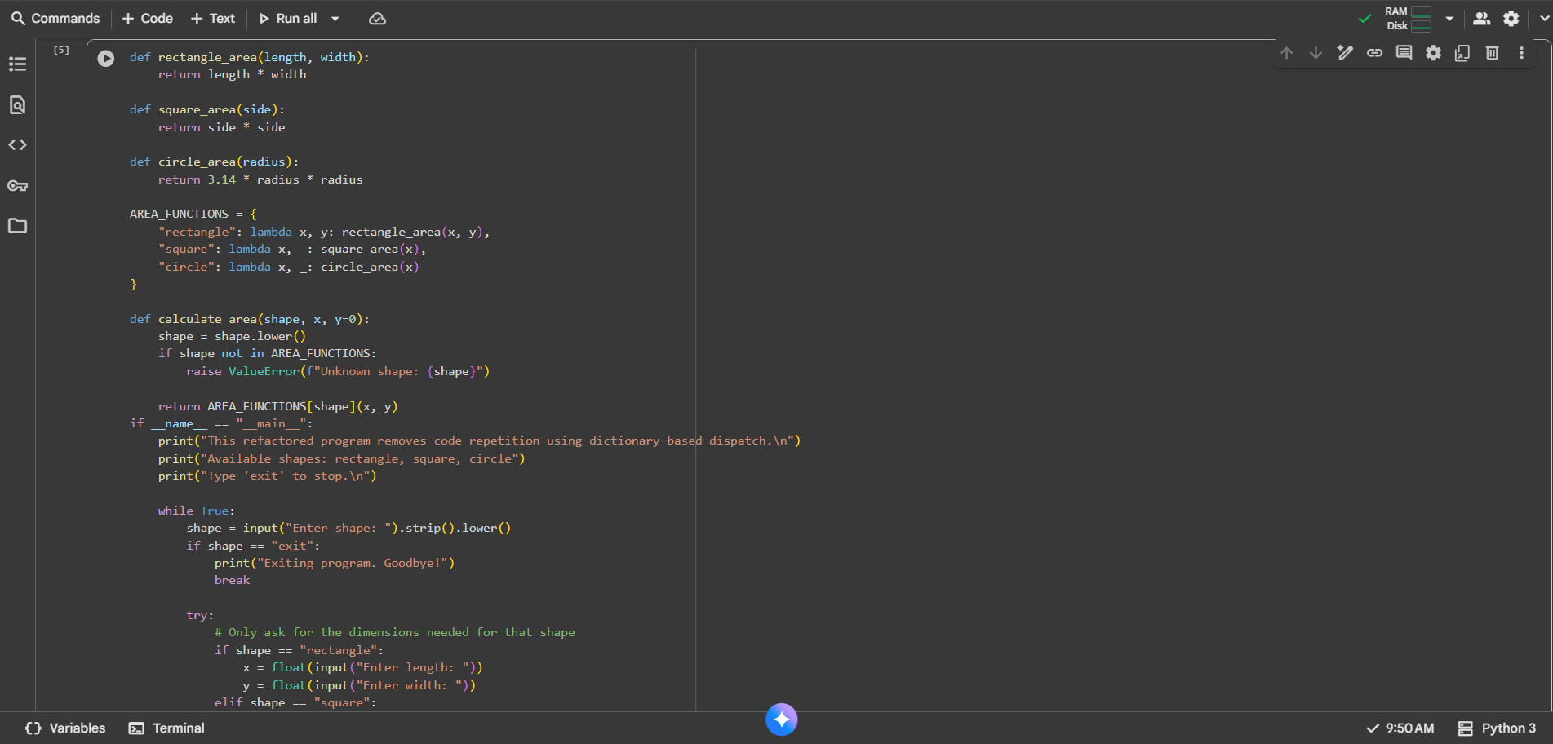  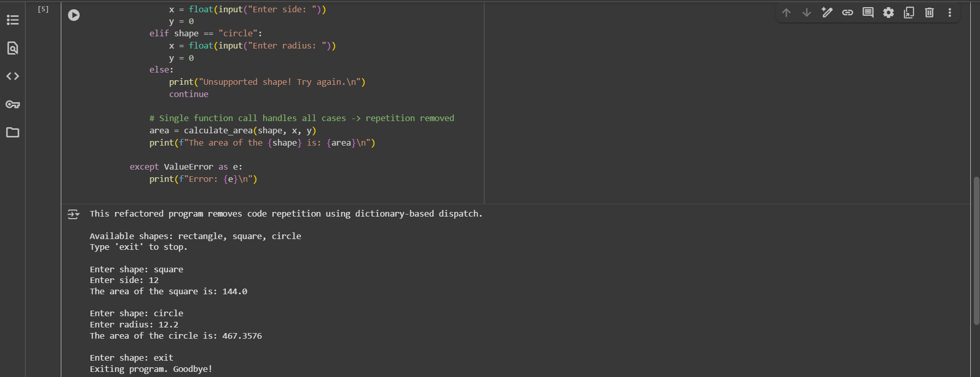  Observation#1:  This code effectively refactors the calculation of geometric areas by using a dictionary to dispatch different area calculation functions based on user input, thereby removing repetitive conditional logic and improving code maintainability and readability.  Task Description #2 – Error Handling in Legacy Code  Task: Legacy function without proper error handling  Python Code  def read_file(filename):  f = open(filename, "r")  data = f.read()  f.close()  return data  Expected Output:  AI refactors with with open() and try-except:  Prompt#2:  - Write a Python function that reads files to use with open() for safe file handling.Add try-except blocks to handle errors like missing files or permission issues.Allow dynamic input so users can enter multiple filenames one by one and display their contents safely.  Code#2:  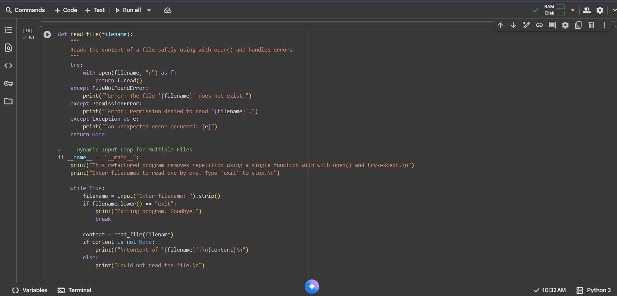  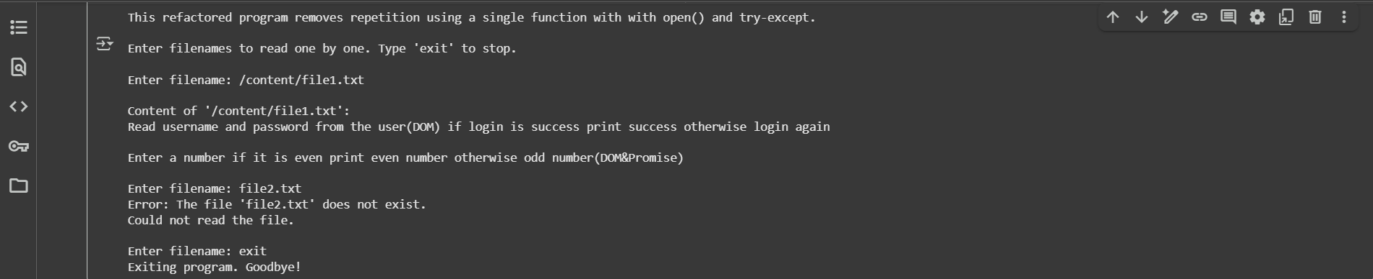  Observation#2:  - This code defines a function read_file to safely read the content of a file using a with open() statement and includes error handling for FileNotFoundError, PermissionError, and other exceptions. The main part of the script prompts the user to enter filenames one by one and uses the read_file function to display the content of each file if successful, or an error message if not. This demonstrates robust file handling and error management in Python.  Task Description #3 – Complex Refactoring  Task: Provide this legacy class to AI for readability and modularity improvements:  Python Code  class Student:  def __init__(self, n, a, m1, m2, m3):  self.n = n  self.a = a  self.m1 = m1  self.m2 = m2  self.m3 = m3  def details(self):  print("Name:", self.n, "Age:", self.a)  def total(self):  return self.m1+self.m2+self.m3  Expected Output:  - AI improves naming (name, age, marks).  - Adds docstrings.  - Improves print readability.  - Possibly uses sum(self.marks) if marks stored in a list.  Prompt#3:  Write a python code that Student class to improve readability and modularity using better naming and docstrings.Store marks in a list to allow flexible handling and use sum() for total calculation.Add dynamic input so multiple students and their marks can be entered, with clear, formatted reports displayed for each.  Code#3:  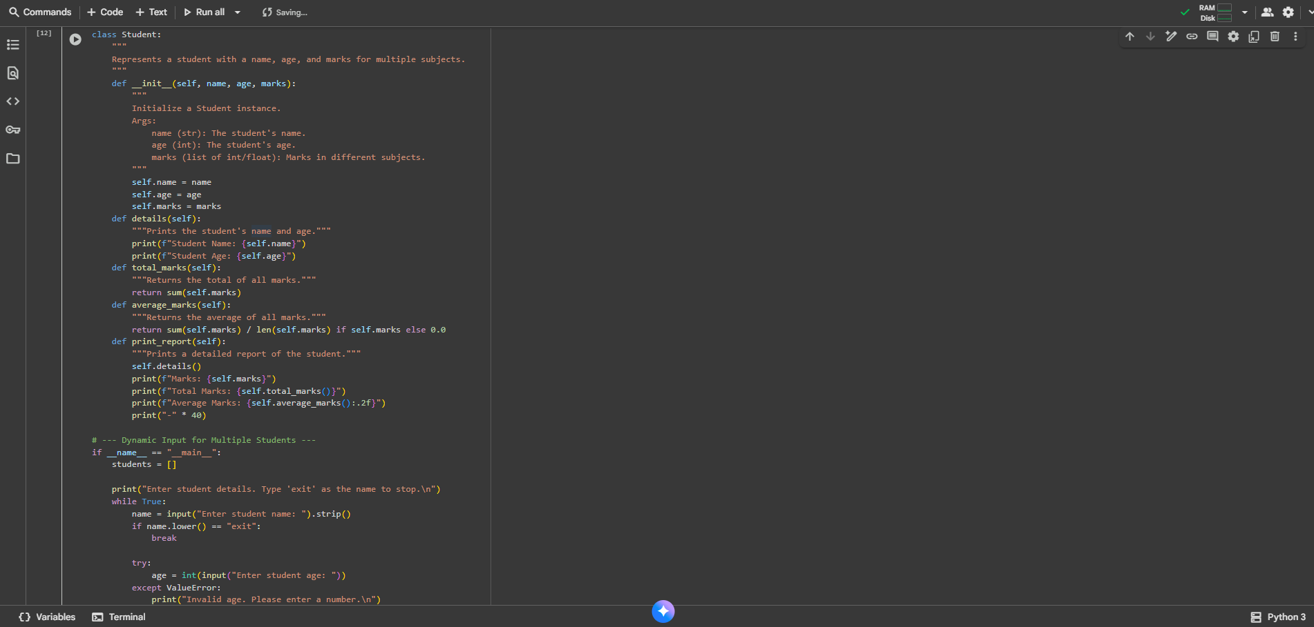  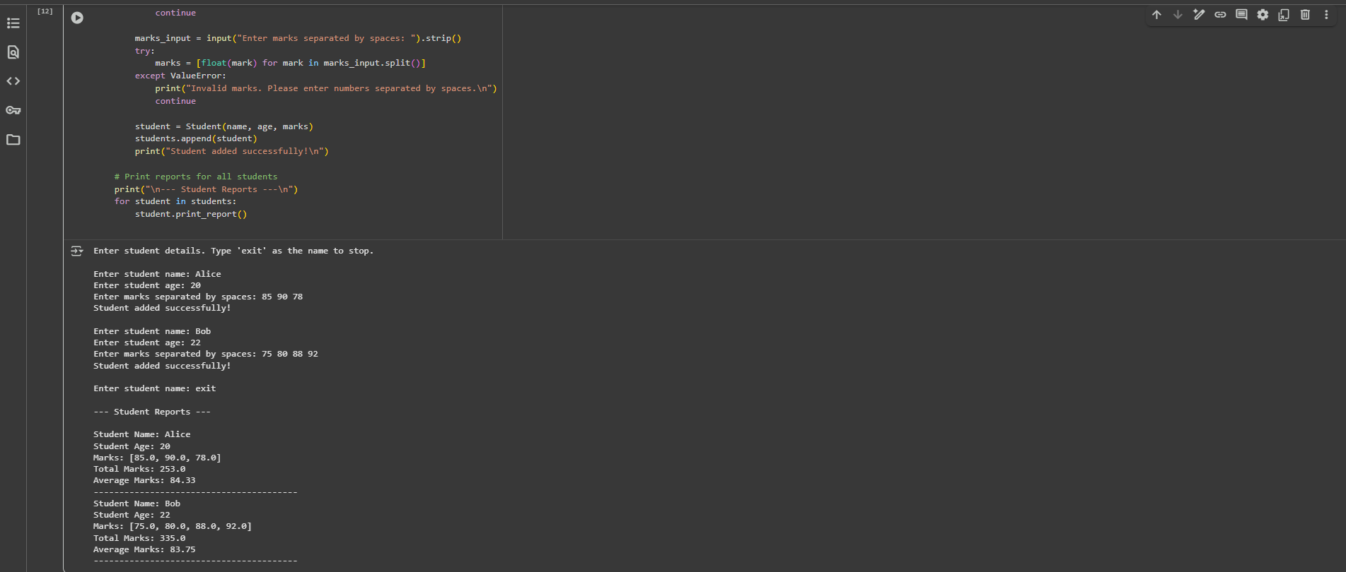  Observation#3:  - This code defines a Student class to manage student data including name, age, and marks. It includes methods to display student details, calculate total and average marks, and print a formatted report. The main part of the script allows dynamic input of multiple student details, storing them in a list, and then iterating through the list to print a report for each student, demonstrating object-oriented programming principles and data handling.  Task Description #4 – Inefficient Loop Refactoring  Task: Refactor this inefficient loop with AI help  Python Code  nums = [1,2,3,4,5,6,7,8,9,10]  squares = []  for i in nums:  squares.append(i * i)  Expected Output: AI suggested a list comprehension  Prompt#4:  - Write a loop that calculates squares of numbers to use list comprehension for efficiency and readability.Allow dynamic input so users can enter multiple numbers separated by spaces.  Include error handling and support repeated inputs until the user chooses to exit.  Code#4:  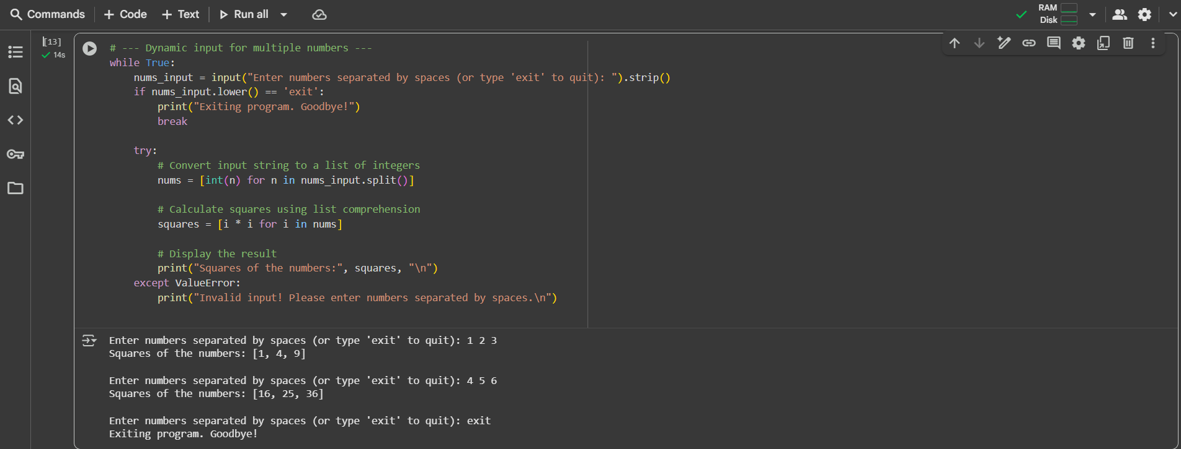  Observation#4:  - This code cell takes user input of numbers separated by spaces, calculates the square of each number using a list comprehension, and then prints the original numbers and their squares. It includes error handling for non-numeric input and allows the user to exit the loop by typing 'exit'. This demonstrates basic input processing, list manipulation, and error handling in Python. |  |  |  |  |  | Week5 - Monday

